Regulatory Committee
Meeting to be held on 27th July 2016

Electoral Division affected:
Brierfield and Nelson North

Wildlife and Countryside Act 1981
Definitive Map Modification Order Investigation
Addition of public footpath from Railway Street to Cross Street Car Park, Brierfield, Pendle Borough
File No. 804-501
(Annex ‘A’ refers)

Contact for further information:
Megan Brindle, 01772 535604, Paralegal Officer, Legal and Democratic Services, megan.brindle@lancashire.gov.uk
Jayne Elliott, 07917 836626, Public Rights of Way, Planning & Environment Group, Jayne.elliott@lancashire.gov.uk

Executive Summary

Application for the addition of a public footpath from Railway Street to Cross Street Car Park, Brierfield, in accordance with File No. 804-501.

Recommendation

That the application for a public footpath from Railway Street to Cross Street Car Park, Brierfield be accepted in part:
- A-B-C-D-E to be added to the Definitive Map and Statement of Public Rights of Way, in accordance with File No. 804-501, to be accepted; and
- E-F-G to be not accepted.

2. That an Order be made pursuant to Section 53 (2)(b) and Section 53 (3)(b) and/or Section 53(3)(c)(i) of the Wildlife and Countryside Act 1981 to add a public footpath from Railway Street to Cross Street Car Park, Brierfield on the Definitive Map and Statement of Public Rights of Way as shown on Committee Plan between points A-B-C-D-E.

3. That being satisfied that the higher test for confirmation can be met the Order be promoted to confirmation.

Background

An application under Schedule 14 of the Wildlife and Countryside Act 1981 has been received for the addition onto the Definitive Map and Statement of Public Rights of Way of a public footpath from Railway Street to Cross Street Car Park, Brierfield; a distance of approximately 60 metres and shown between points A-B-C-D-E-F-G on the Committee plan.

The County Council is required by law to investigate the evidence and make a decision based on that evidence as to whether a public right of way exists, and if so its status. Section 53(3)(b) and (c) of the Wildlife and Countryside Act 1981 set out the tests that need to be met when reaching a decision; also current Case Law needs to be applied.

An order will only be made to add a public right of way to the Definitive Map and Statement if the evidence shows that:
- A right of way “subsists” or is “reasonably alleged to subsist”

An order for adding a way to or upgrading a way shown on the Definitive Map and Statement will be made if the evidence shows that:
- “the expiration… of any period such that the enjoyment by the public…raises a presumption that the way has been dedicated as a public path or restricted byway”

When considering evidence, if it is shown that a highway existed then highway rights continue to exist (“once a highway, always a highway”) even if a route has since become disused or obstructed unless a legal order stopping up or diverting the rights has been made. Section 53 of the Wildlife and Countryside Act 1981 (as explained in Planning Inspectorate’s Advice Note No. 7) makes it clear that considerations such as suitability, the security of properties and the wishes of adjacent landowners cannot be considered. The Planning Inspectorate’s website also gives guidance about the interpretation of evidence.

The County Council’s decision will be based on the interpretation of the evidence discovered by officers and documents and other evidence supplied by the applicant, landowners, consultees and other interested parties produced to the County Council before the date of the decision. Each piece of evidence will be tested and the evidence overall weighed on the balance of probabilities. It is possible that the Council’s decision may be different from the status given in any original application. The decision may be that the routes have public rights as a footpath, bridleway, restricted byway or byway open to all traffic, or that no such right of way exists. The decision may also be that the routes to be added or deleted vary in length or location from those that were originally considered.

Consultations

Pendle Borough Council

Consultations were initially carried out in 2010 and the Borough Council's Engineering and Special Projects Department responded on behalf of one of the land owners, Housing Pendle with the following:
"The application is for the footpath marked A-B-C (A-G on the Committee plan) on the attached map. The section A-B (A-E on the Committee plan) is a section of path surfaced with flagstones. This is evidently fairly well used giving access onto the car park off Cross Street.
From point B-C (E-G on Committee plan) there is no existing public access. It is questionable whether the user evidence is valid for this part of the claimed route. Most users use the path A-B (A-E) and then gain access to Cross Street across the car park.

Older maps show that houses 2-16 Vine Street previously stood on the site of the car park. It can be seen that there was a back street along 2-16 Vine Street. It is possible that this may have carried highway rights for pedestrians. It is less clear whether there was access along the claimed route at the side of 16 Vine Street to the front of Vine Street.

I have briefly discussed this issue with the Council's parking manager and she had indicated that she would have no objection if a public right of way was dedicated across the car park to provide a convenient route from point B (point E on Committee plan) to Cross Street. The applicant may be willing to modify the claim to exclude the section of path B-C (point E-point G) if a creation agreement could be used to give access to Cross Street."

In 2016 additional consultations were carried out as time had lapsed. The Borough Council responded outlining their ownership and provided no comments regarding the application.

The dedication of a route from point E on the Committee plan, across the car park to exit onto Cross Street has not been pursued.

Nelson Town Council

Nelson Town Council were consulted in 2010 and no response was received from them. It is assumed that they have no comments to make.

Brierfield Town Council

Brierfield Town Council were consulted in 2016 and no response has been received, it is also assumed they have no comments to make.

Applicant/Landowners/Supporters/Objectors

The evidence submitted by the applicant/landowners/supporters/objectors and observations on those comments are included in Advice – Head of Service – Legal and Democratic Services Observations.

Advice

Head of Service – Planning and Environment

Points annotated on the attached Committee plan.

Point | Grid Reference (SD) | Description
A | 8456 3643 | Open junction of route with Railway Street adjacent to 27 Railway Street
B | 8456 3645 | Point at which the route appears to narrow on OS maps dating from 1893 (1st edition 25 inch map) to 1932 (3rd edition 25 inch OS map)
C | 8456 3646 | Point at which the route exited onto a back street (no longer in existence) to the rear of a row a terrace houses on Vine Street (now demolished) but shown on OS maps dating from 1893 to 1961.
D | 8456 3647 | Line across route shown on OS maps from 1893 to 1932 at north eastern end of back street adjacent to a property (now demolished)
E | 8456 3647 | Point at which the route now exits onto south west corner of car park
F | 8456 3647 | Line across the route on OS maps dating from 1893 to 1961.
G | 8456 3649 | Unmarked point on ground

Description of Route

A site inspection was carried out on 25 April 2016.

The route commences on Railway Street immediately to the west of 27 Railway Street (point A on the Committee plan). Access onto the route is open and unrestricted adjacent to the gable end of 27 Railway Street (to the east) and a low stone wall (to the west). From point A the route follows a stone flagged path along the edge of the building open to a flagged area to the west where a metal seat is located. The flagged area is overgrown and in disrepair and does not appear to have been maintained recently.

The flags continue from point A to the rear of 27 Railway Street from where the route continues in a generally northerly direction bounded on either side by fencing at a width approximately 1.2 metres. The route is overgrown and difficult to walk between point B and point E on the Committee plan.

At point E the route exits onto a tarmacked car park and continues along the western perimeter of the car park towards point G.

Just south of point F on the Committee plan the route is crossed by wooden fencing forming perimeter fencing of 13 Vine Street and beyond the fencing the route continues for a short distance across the garden of 13 Vine Street to point G.

The total length of the route claimed is 60 metres. When inspected the route was overgrown and difficult to use between point A and point E. From point E access was available in an easterly direction across the car park to exit onto Cross Street or in a north easterly direction across the carpark to the flagged pathway signed as Vine Street. From point E it was possible to walk the line of the route towards point F along the edge of the carpark but from just south of point F the route was blocked by a wooden fence beyond which it continued to an unmarked point in the garden of 13 Vine Street. There was no access to point G along the route or from point G to a publicly recorded highway or 'place of public resort'. Point G does not connect to pathway known as Vine Street.

Map and Documentary Evidence

Document Title | Date | Brief Description of Document & Nature of Evidence
Yates’ Map  of Lancashire | 1786 | Small scale commercial map. Such maps were on sale to the public and hence to be of use to their customers the routes shown had to be available for the public to use. However, they were privately produced without a known system of consultation or checking. Limitations of scale also limited the routes that could be shown.
Observations |  | The route under investigation is not shown.
Investigating Officer's Comments |  | The route probably did not exist.
Greenwood’s Map of Lancashire | 1818 | Small scale commercial map. In contrast to other map makers of the era Greenwood stated in the legend that this map showed private as well as public roads and the two were not differentiated between within the key panel.
Observations |  | The route is not shown.
Investigating Officer's Comments |  | The route probably did not exist.
Hennet's Map of Lancashire | 1830 | Small scale commercial map. In 1830 Henry Teesdale of London published George Hennet's Map of Lancashire surveyed in 1828-1829 at a scale of 71/2 inches to 1 mile. Hennet's finer hachuring was no more successful than Greenwood's in portraying Lancashire's hills and valleys but his mapping of the county's communications network was generally considered to be the clearest and most helpful that had yet been achieved.
Observations |  | The route is not shown.
Investigating Officer's Comments |  | The route probably did not exist.
Canal and Railway Acts |  | Canals and railways were the vital infrastructure for a modernising economy and hence, like motorways and high speed rail links today, legislation enabled these to be built by compulsion where agreement couldn't be reached. It was important to get the details right by making provision for any public rights of way to avoid objections but not to provide expensive crossings unless they really were public rights of way. This information is also often available for proposed canals and railways which were never built.
Observations |  | The route is located to the east of a railway line originally constructed in the mid 1800's by the Lancashire and Yorkshire Railway and known as the Clifton, Accrington and Colne line. No plans or records relating to the construction of the railway have been found which show the route or the land crossed by the route.
Investigating Officer's Comments |  | No inference can be drawn.
Tithe Map and Tithe Award or Apportionment |  | Maps and other documents were produced under the Tithe Commutation Act of 1836 to record land capable of producing a crop and what each landowner should pay in lieu of tithes to the church. The maps are usually detailed large scale maps of a parish and while they were not produced specifically to show roads or public rights of way, the maps do show roads quite accurately and can provide useful supporting evidence (in conjunction with the written tithe award) and additional information from which the status of ways may be inferred.
Observations |  | The Tithe Map for Brierfield has not been examined as it pre dated the construction of the railway and adjacent properties.
Investigating Officer's Comments |  | No inference can be drawn.
Inclosure Act Award and Maps |  | Inclosure Awards are legal documents made under private acts of Parliament or general acts (post 1801) for reforming medieval farming practices, and also enabled new rights of way layouts in a parish to be made. They can provide conclusive evidence of status.
Observations |  | There is no Inclosure Award for the area over which the route is found.
Investigating Officer's Comments |  | No inference can be drawn.
6 Inch Ordnance Survey (OS) Map | 1848 | The earliest Ordnance Survey 6 inch map for this area surveyed in 1844 and published in 1848.
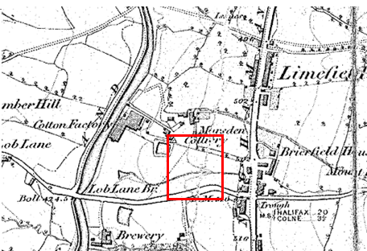
Observations |  | The route is not shown. The road now known as Railway Street can be seen but the railway is not shown and the area crossed by the route is undeveloped.
Investigating Officer's Comments |  | The route did not exist in 1844.
25 Inch OS Map | 1893 | The earliest OS map at a scale of 25 inch to the mile. Surveyed in 1891 and published in 1893.
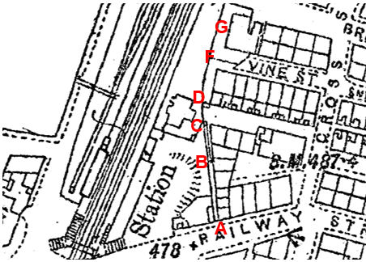
Observations |  | The railway is shown, together with the railway station west of the route. Railway Street is shown and named and a bounded strip of land corresponding to the alignment of the route is shown from point A extending in a generally northerly direction to point B. A line is shown across the route at point A and a further line is shown across it at point B beyond which there a line marked along the middle of the enclosed strip of land (the route) to the point at which it exits out onto an unnamed street at point C. The unnamed 'street' is to the rear of a number of terraced properties built along the south side of Vine Street (named). The route crosses the western end of the 'un-named street' to point D where it passes through a small rectangular shaped feature beyond which there is a strip of land consistent with the position of the route between point D and point F. At point F the route is crossed by a further line and continues north to terminate at an unmarked point on a strip of land immediately to the west of a property at the north western end of Vine Street. Vine Street (on its original alignment) is shown and named on the map but ends further east than the route and does not connect to it.
Investigating Officer's Comments |  | Development had taken place in the later part of the 1800s including the construction of the railway, a number of terraced houses and Vine Street. Vine Street did not extend as far as point G. Parts of the route appear to have existed in 1891 but there are a number of lines shown across it suggesting that access may have been restricted and from point D to point G the route appears to have crossed the enclosed gardens of two properties. The route does not appear to have formed a through route from point A to point G when the area was surveyed by the Ordnance Survey in 1891.
25 inch OS Map | 1912 | Further edition of the 25 inch map surveyed in 1891, revised in 1910 and published in 1912.
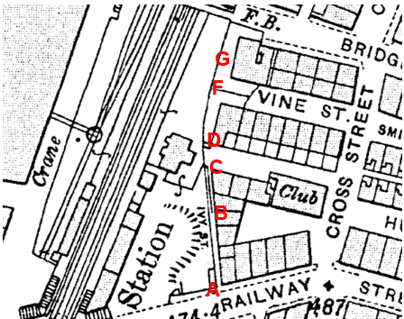
Observations |  | The route is shown between point A and point C and is named as Ivy Street. Access onto the route is open at point A. The route is shown bounded on either side but from point B the width appears to be reduced by a line running down the middle to point C. From point C the route continues in a generally northerly direction across the eastern end of an unnamed street to point D. Immediately south of point D there is a small enclosed rectangular area of land which may have prevented or restricted access. Beyond point D to point F the route crosses a piece of land bounded to the east by the gable end of a row of terrace houses and is crossed by a line at point F. It then continues in a generally northerly direction across land to the west of a further property on Vine Street to an unmarked point to the west of a property.
Investigating Officer's Comments |  | The route existed in 1910 between point A and point C and was named as Ivy Street providing access through to an unnamed street at point C. Access though point D to point G does not appear to have been available and a through route does not appear to have existed connecting Railway Street to Vine Street. The configuration of boundaries on the land crossed by the route between point D and point G is suggestive of the enclosure of garden areas belonging to the two most westerly properties on Vine Street.
Finance Act 1910 Map | 1910 | The comprehensive survey carried out for the Finance Act 1910, later repealed, was for the purposes of land valuation not recording public rights of way but can often provide very good evidence. Making a false claim for a deduction was an offence although a deduction did not have to be claimed so although there was a financial incentive a public right of way did not have to be admitted.  Maps, valuation books and field books produced under the requirements of the 1910 Finance Act have been examined. The Act required all land in private ownership to be recorded so that it could be valued and the owner taxed on any incremental value if the land was subsequently sold. The maps show land divided into parcels on which tax was levied, and accompanying valuation books provide details of the value of each parcel of land, along with the name of the owner and tenant (where applicable).  An owner of land could claim a reduction in tax if his land was crossed by a public right of way and this can be found in the relevant valuation book. However, the exact route of the right of way was not recorded in the book or on the accompanying map. Where only one path was shown by the Ordnance Survey through the landholding, it is likely that the path shown is the one referred to, but we cannot be certain. In the case where many paths are shown, it is not possible to know which path or paths the valuation book entry refers to. It should also be noted that if no reduction was claimed this does not necessarily mean that no right of way existed.
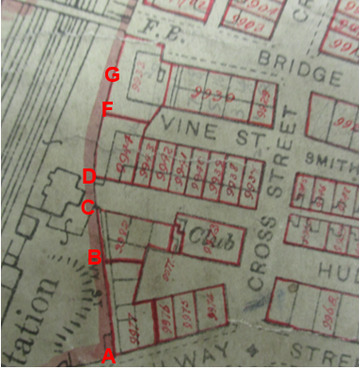
Observations |  | The Valuation Maps and Records held by the County Records Office were examined.  Between point A and point B the route was included in plot 9977 and between point B and point C it was included in plot 9982. Both plots were recorded as being privately owned and occupied and no deductions were claimed for public rights of way or user. Between point C and point D the route is not included within any numbered plots but is shown to be part of the un-named street connecting to Cross Street and bounded on either side by numbered plots. Between point D and point F the route is included within plot 9944 and from point F to point G it is within plot 9933 both of which were recorded as being privately owned and occupied properties for which no deductions were listed for public rights of way or user.
Investigating Officer's Comments |  | The Valuation records do not provide any supporting evidence regarding the existence of the route in 1910. Only the section between point C and point D is excluded from the numbered plots which indicates that it may have been considered to be part of a public vehicular route at that time.  Public Footpaths are not normally excluded from numbered plots. The fact that no deductions are claimed suggests that the route between point A-B-C and point D-E-F-G was not considered to be a public footpath – or that the landowners did not wish to claim for and acknowledge its existence at that time.
25 Inch OS Map | 1932 | Further edition of 25 inch map (surveyed 1891, revised in 1929 and published 1932.
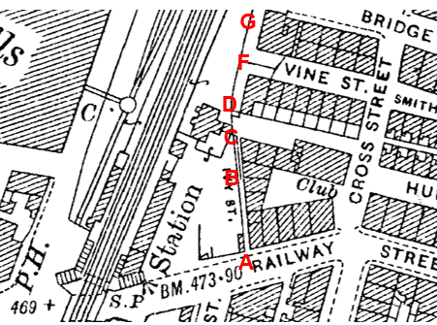
Observations |  | The map remains unaltered from the earlier edition published in 1912.
Investigating Officer's Comments |  | The route between point A and point C appears to have existed when the map was revised in 1929 and was known as Ivy Street. It could be accessed from an unnamed back street shown as connecting to Cross Street.  The route from point D to point G probably did not exist in 1929.
Authentic Map Directory of South Lancashire by Geographia | Circa1934 | An independently produced A-Z atlas of Central and South Lancashire published to meet the demand for such a large-scale, detailed street map in the area. The Atlas consisted of a large scale coloured street plan of South Lancashire and included a complete index to streets which includes every 'thoroughfare' named on the map.  The introduction to the atlas states that the publishers gratefully acknowledge the assistance of the various municipal and district surveyors who helped incorporate all new street and trunk roads. The scale selected had enabled them to name 'all but the small, less-important thoroughfares'.
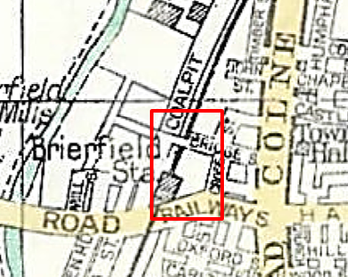
Observations |  | The route is not shown. Railway Street is shown and the area within which the route is contained is shown bounded by Cross Street, Bridge Street and the railway. None of the houses or roads providing direct access to the houses within this area are shown.
Investigating Officer's Comments |  | The route (or part of it) may have existed and may have been capable of being used. However, the scale of the map and the purpose for which it was produced means that in built up urban areas in particular, only those routes considered to carry public vehicular rights were likely to be shown.
Aerial Photograph | 1940s | The earliest set of aerial photographs available was taken just after the Second World War in the 1940s and can be viewed on GIS. The clarity is generally very variable.
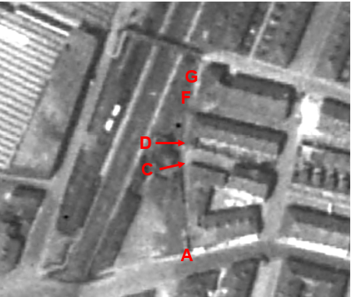
Observations |  | The clarity of the photograph makes it impossible to see whether the route was accessible in the 1940s. However, the outline of the buildings appears to be consistent with the 25 inch OS map published in 1932 and a line can be seen from point A to point C suggesting that this part of the route probably existed at that time and that access was available from point C onto the unnamed street linking to Cross Street. It is not possible to see whether access was available through point D to point F and point G. A route can be seen from close to point F passing through point G and continuing in a generally north easterly direction to exit onto Bridge Street.
Investigating Officer's Comments |  | The aerial photograph is consistent with what is shown on OS mapping around that time but it is not possible to see with any certainty whether the route – or any part of it – was accessible.
1: 2500 OS Map | 1961 | Further edition of 25 inch map reconstituted from former county series and revised in 1959 and published 1961 as national grid series.
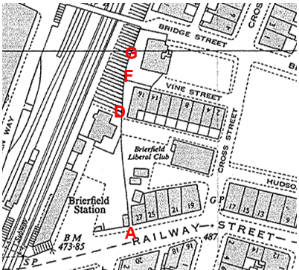
Observations |  | The area has undergone some changes since the earlier OS mapping detailed above. Access onto the route at point A is open and the route appears to be available through to point C where it connects to the unnamed street providing a link through to Cross Street. Access may have been available from point D alongside 16 Vine Street but the route is then crossed by a line at point F. No route is marked on the map between point D and point G and the land crossed by the route between these two points still appears to form the gardens of two properties at the western end of Vine Street.
Investigating Officer's Comments |  | The route may have existed between point A and point C connecting to an unnamed street. The route from point C to point D crossed the western end of the unnamed street and from point D to point G it does not appear that the route existed.
Aerial photograph | 1960s | The black and white aerial photograph taken in the 1960s and available to view on GIS.
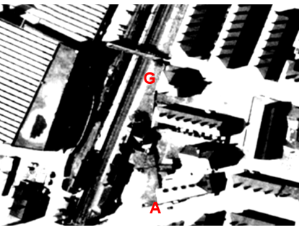
Observations |  | It is not possible to see whether the route existed on the aerial photograph. A fence appears to exist to the west of the end of Vine Street which, if it did exist, may have prevented or restricted access from the route onto Vine Street at this point.
Investigating Officer's Comments |  | No inference can be drawn.
OS 1:1250 Map | 1979 | 1:1250 OS plan obtained from land registry, published 1979, date of revision unknown
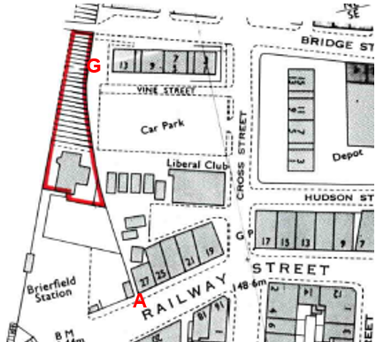
Observations |  | By the time that the OS published their 1:1250 map in 1979 properties 2 – 16 Vine Street had been demolished together with the larger property which had previously existed at the north west end of Vine Street. New properties along the north side of Vine Street had been built and Vine Street itself had been shifted to the north.  The route is not shown as a defined feature but access appears to be available along the full length. Vine Street is shown extending further west than it is now shown but does not connect to point G.
Investigating Officer's Comments |  | Access may have been available along the full length of the route in 1979.
Aerial Photograph | 2000 | Aerial photograph available to view on GIS.
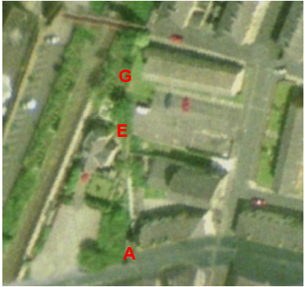
Observations |  | Further changes have taken place since 1979 with the car park area being altered to provide a grassed area in front (south) of 13 Vine Street.  The route appears to be accessible between point A and point E and is quite clearly shown on the photograph. From point E it appears that access was available across the car park to exit onto Vine Street or Cross Street. It is not possible to see whether access was available between point E and point G.
Investigating Officer's Comments |  | Between point A and point E the route appeared capable of being used in and a defined route can be seen. Access across the car park to exit onto Cross Street appears to be available. No inference can be drawn regarding access between point E and point G.
Aerial Photograph | 2010 | Aerial photograph available to view on GIS.
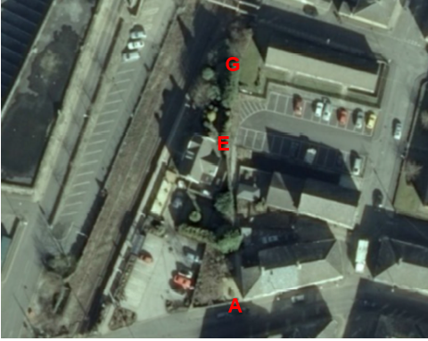
Observations |  | On the aerial photograph taken in 2010 it is possible to see the landscaped area and flagging that had been carried out near point A at least a year earlier (see Google street view photographs later in report) and a well-defined route is visible from point A to exit the car park at point E. From point E to point G the route is not visible on the ground and appears to be crossed by fencing close to point F.
Investigating Officer's Comments |  | The route existed between point A and point E in 2010. Beyond point E it appeared possible to exit onto the car park to continue onto Vine Street or Cross Street. The route between point E and point G did not appear to exist.
Definitive Map Records |  | The National Parks and Access to the Countryside Act 1949 required the County Council to prepare a Definitive Map and Statement of Public Rights of Way.  Records were searched in the Lancashire Records Office to find any correspondence concerning the preparation of the Definitive Map in the early 1950s.
Parish Survey Map | 1950-1952 | The initial survey of public rights of way was carried out by the parish council in those areas formerly comprising a rural district council area and by an urban district or municipal borough council in their respective areas. Following completion of the survey the maps and schedules were submitted to the County Council. In the case of municipal boroughs and urban districts the map and schedule produced, was used, without alteration, as the Draft Map and Statement. In the case of parish council survey maps, the information contained therein was reproduced by the County Council on maps covering the whole of a rural district council area. Survey cards, often containing considerable detail exist for most parishes but not for unparished areas.
Observations |  | Brierfield was an Urban District Council
Draft Map |  | The Draft Maps were given a “relevant date” (1st January 1953) and notice was published that the draft map for Lancashire had been prepared. The draft map was placed on deposit for a minimum period of 4 months on 1st January 1955 for the public, including landowners, to inspect them and report any omissions or other mistakes. Hearings were held into these objections, and recommendations made to accept or reject them on the evidence presented.
Observations |  | The route under investigation was not shown on the Draft Map of Public Rights of Way for Brierfield and there were no representations made to the County Council in relation to it.
Provisional Map |  | Once all representations relating to the publication of the draft map were resolved, the amended Draft Map became the Provisional Map which was published in 1960, and was available for 28 days for inspection. At this stage, only landowners, lessees and tenants could apply for amendments to the map, but the public could not. Objections by this stage had to be made to the Crown Court.
Observations |  | The route under investigation was not shown on the Provisional Map and there were no representations made to the County Council in relation to it.
The First Definitive Map and Statement |  | The Provisional Map, as amended, was published as the Definitive Map in 1962.
Observations |  | The route under investigation was not shown on the First Definitive Map and Statement.
Revised Definitive Map of Public Rights of Way (First Review) |  | Legislation required that the Definitive Map be reviewed, and legal changes such as diversion orders, extinguishment orders and creation orders be incorporated into a Definitive Map First Review. On 25th April 1975 (except in small areas of the County) the Revised Definitive Map of Public Rights of Way (First Review) was published with a relevant date of 1st September 1966. No further reviews of the Definitive Map have been carried out. However, since the coming into operation of the Wildlife and Countryside Act 1981, the Definitive Map has been subject to a continuous review process.
Observations |  | The route under investigation is not shown on the Revised Definitive Map of Public Rights of Way (First Review).
Investigating Officer's Comments |  | From 1953 through to 1975 there is no indication that the route under investigation was considered to be a public right of way by the Surveying Authority. There were no objections to the fact that the route was not shown from the public when the maps were placed on deposit for inspection at any stage of the preparation of the Definitive Map.
Highway Adoption Records including maps derived from the '1929 Handover Maps' | 1929 to present day | In 1929 the responsibility for district highways passed from district and borough councils to the County Council. For the purposes of the transfer, public highway 'handover' maps were drawn up to identify all of the public highways within the county. These were based on existing Ordnance Survey maps and edited to mark those routes that were public. However, they suffered from several flaws – most particularly, if a right of way was not surfaced it was often not recorded.  A right of way marked on the map is good evidence but many public highways that existed both before and after the handover are not marked. In addition, the handover maps did not have the benefit of any sort of public consultation or scrutiny which may have picked up mistakes or omissions.  The County Council is now required to maintain, under section 31 of the Highways Act 1980, an up to date List of Streets showing which 'streets' are maintained at the public's expense. Whether a road is maintainable at public expense or not does not determine whether it is a highway or not.
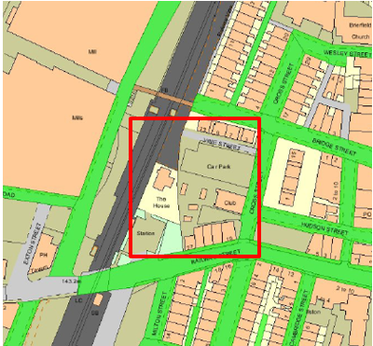
Observations |  | The route is not recorded as being publicly maintainable on the List of Streets and Vine Street, to which the Applicant described the route connecting to, is not shown as being publicly maintainable.
Investigating Officer's Comments |  | No inference can be drawn regarding public rights.
Highway Stopping Up Orders | 1835 - 2016 | Details of diversion and stopping up orders made by the Justices of the Peace and later by the Magistrates Court are held at the County Records Office from 1835 through to the 1960s. Further records held at the County Records Office contain highway orders made by Districts and the County Council since that date.
Observations |  | A search was made to see whether any record could be found of the stopping up or diversion of Ivy Street, Vine Street or the un-named street from the route to Cross Street. No reference to the route or streets listed being stopped up or diverted could be found.
Investigating Officer's Comments |  | No inference can be drawn.
Statutory deposit and declaration made under section 31(6) Highways Act 1980 |  | The owner of land may at any time deposit with the County Council a map and statement indicating what (if any) ways over the land he admits to having been dedicated as highways. A statutory declaration may then be made by that landowner or by his successors in title within ten years from the date of the deposit (or within ten years from the date on which any previous declaration was last lodged) affording protection to a landowner against a claim being made for a public right of way on the basis of future use (always provided that there is no other evidence of an intention to dedicate a public right of way).  Depositing a map, statement and declaration does not take away any rights which have already been established through past use. However, depositing the documents will immediately fix a point at which any unacknowledged rights are brought into question. The onus will then be on anyone claiming that a right of way exists to demonstrate that it has already been established. Under deemed statutory dedication the 20 year period would thus be counted back from the date of the declaration (or from any earlier act that effectively brought the status of the route into question).
Observations |  | No Highways Act 1980 Section 31(6) deposits have been lodged with the County Council for the area over which the route runs.
Investigating Officer's Comments |  | There is no indication by a landowner under this provision of non-intention to dedicate public rights of way over their land.
Google Street View | 2009 | Photographs available to view online.
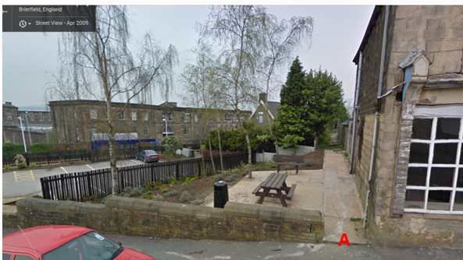
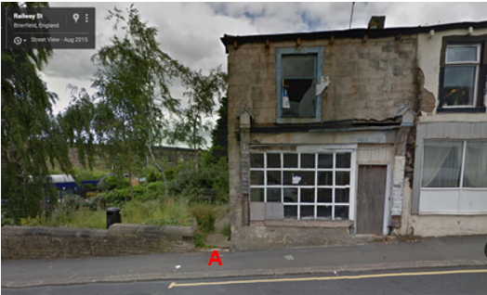
Observations |  | The 2009 photograph shows the landscaping work that had been carried out by the Pendle Borough Council Environmental Action Group. The newly laid flags extend from point A along the route towards point B but do not appear to continue much beyond the rear of the property (27 Railway Street).  The photograph taken in 2015 shows that access onto the route was still available but that it had become overgrown.  No photographs were available on Google Street View of point G.
Investigating Officer's Comments |  | The route from point A was available to use in 2009 and work had been carried out to include it as part of a more attractive area to access.  The route was still available to access at point A in 2015 but was more overgrown.
Photograph submitted by the Applicant | 2010 | Photograph submitted to LCC by applicant showing that notice of application had been posted on site.
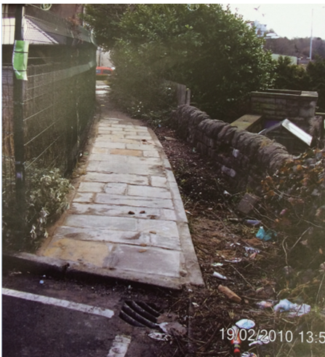
Observations |  | The photograph shows the route from point E looking back towards point A and confirms that the full length of the route from point A to point E had been flagged as part of environmental improvement works.
Investigating Officer's Comments |  | The route existed and was available to use in 2010.

The affected land is not designated as access land under the Countryside and Rights of Way Act 2000 and is not registered common land.

Landownership

The landowners affected by the application are as follows:
Jonathan Howard Roberts and Janet Ann Thain, Clungunford House, Clungunford, Craven Arms SY7 0QL – land affects Point A and near Point B shown on the committee plan
The Residential Organisation Limited, Molteno House, Regents Park Road, London N3 2JX – land affects Point C shown on the committee plan
Wendy Michelle Goodall, Station House, Railway Street, Brierfield, Nelson BB9 5PJ – land affects Point C shown on the committee plan
Pendle Borough Council have leases near Points F and G shown on the committee plan
Part of this route is unregistered.

Summary

The route is not shown to exist on any of the early commercial maps or the First Edition 6 inch map published in 1848 and the area it crossed was shown as being undeveloped.

By 1891 the railway had been built together with the houses adjacent to the start of the route at point A and the houses on Vine Street. The route may have existed in 1891 between point A and point C at which point it exited onto an un-named street providing access to the rear of the properties on Vine Street. No record of the un-named street being recorded as a public highway could be found and it no longer physically exists since the demolition of the houses on Vine Street sometime between the 1960s and 1979.

The 1912 edition of the 25 inch OS clearly shows the route between point A and point C and it is named on the map as Ivy Street. It appears to provide access between Railway Street and the western end of the un-named back street and all OS maps examined through to the current day support the existence of this part of the route.

Between point D and point G the route did not appear to exist prior to the demolition of Vine Street and the houses along either side of it and appears to have crossed private gardens/yards and looks unlikely to have been accessible as a public footpath.

When the houses on Vine Street were demolished and the area redeveloped it appears that access along the route between point A-B-C was unaffected and that a route between point C-D-E came into being providing a link through to the car park area.

From point E-F-G no supporting map or documentary evidence has been found regarding the use or existence of the route.

In conclusion, a route appears to have physically existed since at least 1910 (and possibly from the 1890s) between point A-B-C although no documentary evidence was found supporting the existence of the route as a public highway.

In addition, since at least 1979, following the redevelopment of part of the land crossed by the route it appears that access has also been available from point C to the car park at point E although no documentary evidence was found supporting the existence of this part of route as a public highway.

Work to resurface the route from point A to point E was carried out sometime around 2009 by an Environmental Project team working with Pendle Borough Council suggesting use was being made of the route by the public at that time and supporting the user evidence submitted as part of the application.

Head of Service – Legal and Democratic Services Observations

In support of the application the applicant has provided copies of 6 user evidence forms, the information provided on these forms is summarised below.

5 users stated that they have known the route for 20, 22, 25, 30 & 55 years and one user did not provide a response to this question. All 6 users have used the route on foot and have not provided any details of using the route by any other means. The years in which the users have used the route varies from 1970s – present time, 1986-1999, to 'periodically', 'donkey's years' and all the 55 years that specific user has known the route.

The main places the users were going to and from include Brierfield shopping centre, Railway Street, bus stop, shops, Town Hall, King Street and Veevers Street. The main purposes for using this route are for visiting shops, hairdressers, to catch a bus, to reach home and to visit friends.

4 users agree the route has always run along the same line and all the users agree that there are not stiles / gates / fences along the route and none of the users have ever worked for a landowner or have been a tenant for any of the land over which the route crosses. None of the users have ever been stopped or turned back when using the route, nor have they heard of anyone else being stopped or turning back, they have never been told that the route they were using was not a Public Right of Way and have never seen any signs along the route and never asked permission to use the route.

At the end of completing the user evidence form, users are asked to provide any additional information they have, this information is set out below.

- "The Brierfield group who looks after the railway station and surrounding garden round the car park re-flagged the beginning of the footpath and an extended part of the area on the left side of the footpath to make a picnic area. Who gave them the permission to do this? No one so it's not private land."
- " Remember houses and street (Ivy Street?) and a way out onto Railway Street for Mill Workers. Was a short cut, was a house, made meals for workers a long time ago. Pathway had old York stone slabs down. Stolenin recent years??"
- "Around 1989 the Council did the path up. Lots of people used it then. Well it wasn’t long before. Someone came along and took up lots of flags so we can't use the path now. Council car park. Was easy to get to catch a train using the path."
- "This path has been there for as long as I can remember by me and lots of friends over many years as a short cut. I have lived in Brierfield all my life."

In addition to the 6 user evidence forms the applicant has provided copies of the 1940's & 1960's Aerial Photographs.

Responses from others and landowners

Consultations were carried out in 2010 and 2016 with the landowners and no responses have been received apart from the response received from Pendle Borough Council on behalf of Pendle Housing Limited in 2010 as above.

Assessment of the Evidence

The Law - See Annex 'A'

In Support of Making an Order(s)

- User evidence
- Ordnance Survey Maps
- Arial Photographs
- Google Images
- Photograph submitted by the Applicant
- Absence of gates/fences/stiles along the route
- Absence of signs and notices along the route
- Absence of action taken by landowners to discourage the use of the route

Against Making an Order(s)

- Relatively low user numbers if considering user evidence
- Route not shown on any of the early commercial maps

Conclusion

The claim is that the route A-B-C-D-E-F-G is an existing public footpath and should be added to the Definitive Map and Statement of Public Rights of Way.

It is therefore advised as there is no express dedication that the Committee should
consider, on balance, whether there is sufficient evidence from which to have its
dedication inferred at common law from all the circumstances or for the criteria in
section 31 Highways Act 1980 for a deemed dedication to be satisfied based on
sufficient twenty years “as of right” use to have taken place ending with this use
being called into question. All evidence would appear to relate to the route A-B-C-D-E only and therefore the evaluation is on this basis.

Considering initially the criteria for a deemed dedication under section 31 of the Highways Act, that use needs to be "as of right" and also sufficient for the 20 year period. The first consideration is to determine whether the route is called into question. In this matter the evidence indicates that access to the route has never been questioned or denied and therefore it is suggested on balance that the "calling into question" would be the application itself in 2009 and that the 20 year period under consideration would therefore be 1989-2009.

Six user evidence forms have been submitted of which one has been completed by the applicant. All six users claim to have known and used the route on foot "as of right". The six users indicate knowledge and use of part of the claimed route A-B-C-D-E for a continuous period of 20 years or more without interruption suggesting good user evidence for the sufficient period. None of the users confirm to have knowledge of any stiles, gates or fences across the route neither have they ever been stopped or turned back whilst using the route on foot or have knowledge of others having been stopped or turned back. None of the users have seen any signs or notices along the route, have asked permission to use the route or been told that the route that they were using was a Public Right of Way. It is therefore suggested that there does not appear to be any evidence to demonstrate a lack of intention to dedicate over the twenty years prior to 2009.

The main purposes for using the route claimed by the users is for access to local amenities including going to and from the Brierfield shopping centre, the bus stop, shops, Town Hall and the hairdressers. Users also claim to have used the route to go to and from Railway Street, King Street and Veevers Street and to reach home and visit friends supporting a route from A-B-C-D-E.

In response to the consultations carried out in 2010 a response was received from Pendle Borough Council on behalf of one of the landowners providing further evidence with regards to the use of the route A-B-C-D-E. However, the response questions the validity of any user evidence relating to the route E-F-G.

Considering also whether there are circumstances from which dedication could be inferred at common law. Whilst the route is not shown to exist on any of the early commercial maps and there is no documentary evidence to support the existence of the route as a public highway the map evidence does suggest that it is possible that part of the route between points A-B-C may have existed in 1891. Further evidence of the existence of the route A-B-C is provided by the 1912 25 inch OS map and on all subsequent OS maps to the current day.

The evidence examined in respect of the claimed route D-E-F-G appears to show that this section of the route could not have come into existence until the re-alignment of Vine Street and the redevelopment of the surrounding area first noted by the time that the OS published their 1:1250 OS map in 1979. Prior to this it is considered unlikely that the route D-E-F-G would have been accessible as a public footpath due to it having crossed the gardens of private residential properties.

It would appear that the route between points C-D-E providing a link through to the car park area also came into existence as a result of the changes at Vine Street. The route between points A-B-C-D-E is quite clearly shown on the 2000 and 2010 arial photographs. However, beyond point E the route appears to exit across the car park to continue to Vine Street or Cross Street. The Google Street View photographs provide further evidence of the access to the route from point A and the 2010 photograph provided by the applicant provides evidence of the existence of the route between points A-B-C-D-E.

Further to this, it is suggested that the resurfacing work carried out to the route between points A-B-C-D-E in or around 2009 provides additional evidence to support the user evidence submitted in support of the application.

No supporting map evidence has been found showing the existence of the route between points E-F-G.

It is suggested that the way this route is recorded on documentary evidence is not itself sufficient circumstances from which dedication could be inferred, however, sufficient as of right use acquiesced in by the owners may also be circumstances from which dedication can be inferred. The use as evidenced corroborated by the documentary evidence outlined above would suggest that on balance there are sufficient circumstances to infer at common law that the owners in 1989 to 2009, in acquiescing in the use and taking no overt actions actually intended dedicating the route as a footpath and it had become a footpath accepted by the public.

Taking all of the evidence into account, the Committee on balance may consider that the provisions of section 31 Highways Act can be satisfied and there is also sufficient evidence on balance from which to infer dedication at common law of a footpath in this matter and the claim can be accepted in part.

Risk Management

Consideration has been given to the risk management implications associated with this claim. The Committee is advised that the decision taken must be based solely on the evidence contained within the report, and on the guidance contained both in the report and within Annex 'A' included in the Agenda Papers. Provided any decision is taken strictly in accordance with the above then there is no significant risks associated with the decision making process.

Alternative options to be considered - N/A

Local Government (Access to Information) Act 1985

List of Background Papers

Paper | Date | Contact/Directorate/Tel
All documents on File Ref: 804-501 | Various | Megan Brindle , 01772 535604, Legal and Democratic Services
Reason for inclusion in Part II, if appropriate

N/A

The Ordnance Survey (OS) has produced topographic maps at different scales (historically one inch to one mile, six inches to one mile and 1:2500 scale which is approximately 25 inches to one mile). Ordnance Survey mapping began in Lancashire in the late 1830s with the 6-inch maps being published in the 1840s. The large scale 25-inch maps which were first published in the 1890s provide good evidence of the position of routes at the time of survey and of the position of buildings and other structures. They generally do not provide evidence of the legal status of routes, and carry a disclaimer that the depiction of a path or track is no evidence of the existence of a public right of way.
Aerial photographs can show the existence of paths and tracks, especially across open areas, and changes to buildings and field boundaries for example. Sometimes it is not possible to enlarge the photos and retain their clarity, and there can also be problems with trees and shadows obscuring relevant features.

